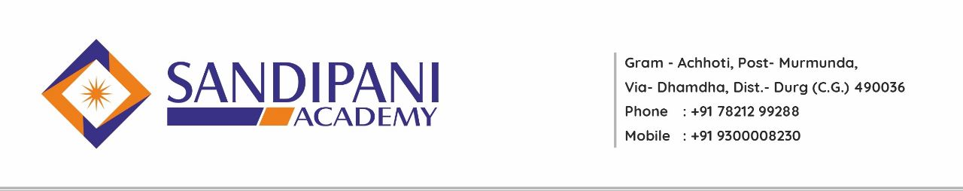
Academic Calendar
B. Ed IV Semester
Session 2022-2023

Date: - 29/11/2022
Month | Activities Academic |  | Co-curricular Activities
December  2022 | Introduction of Syllabus  Commencement of Classes  One Unit of Each Subject including  Elective Subject  Orientation Lecture On Psychometric Practical |  | Assembly ( NEWS Reading, Thought of the Day),  Guest Lectures  Life Skill Program  National Days Celebration  Co-Curricular Activities
January 2023 | One Unit of Each Subjects including  Elective Subjects  Project Work On Yoga And Sports  Psychometric Assessment Practical |  | Assembly ( NEWS Reading, Thought of the Day),  Guest Lectures  Life Skill Program  National Days Celebration  Co-Curricular Activities
February  2023 | One Unit of Each Subject including  Elective Subject  Providing Assignment  Psychometric Assessment Practical  Submission of Project Work on Yoga and Sports  Unit Test  Lesson Plan and Microteaching ( Preparation of Viva) |  | Assembly ( NEWS Reading, Thought of the Day),  Guest Lectures  Life Skill Program  National Days Celebration  Sports Day Celebration  Guest Lecture  Co-Curricular Activities
March  2023 | One Unit of Each Subject including Elective Subject |  | Assembly ( NEWS Reading, Thought of the Day),  Guest Lectures  Life Skill Program  National Days Celebration  Guest Lecture  Co-Curricular Activities
April  2023 | One Unit of Each Subject including Elective Subject  Preparation of Practical Exam |  | Assembly ( NEWS Reading, Thought of the Day)  Guest Lectures  Life Skill Program  National Days Celebration  Guest Lecture  Students Submission of Examination Form
May  2023 | Remedial Class  Model Examination  University Practical Exam ( Psychometric and Viva-Voce on Teaching Experience) |  | Assembly ( NEWS Reading, Thought of the Day),  Guest Lectures  Life Skill Program  National Days Celebration  Guest Lecture
June 2022 |  | University Examination

Principal/ H.O.D

